1. **Screen Shots of Dashboard**
2. **AWS Login Dashboard**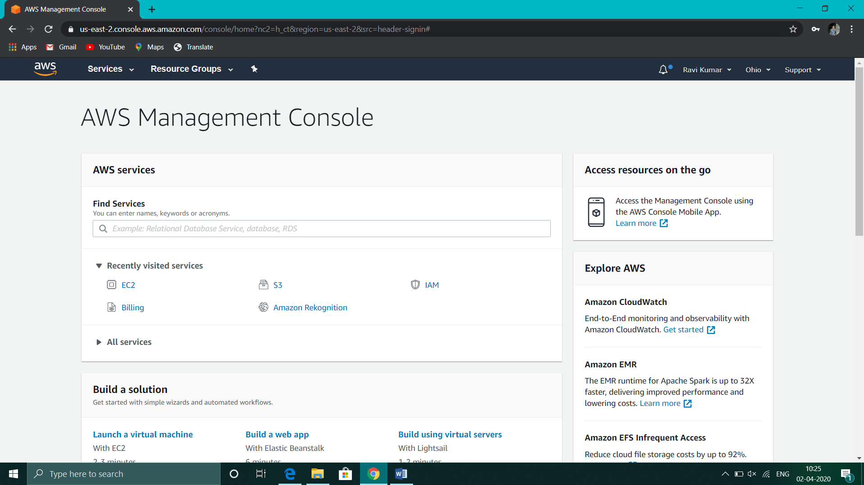
3. **EC2 Dashboard**

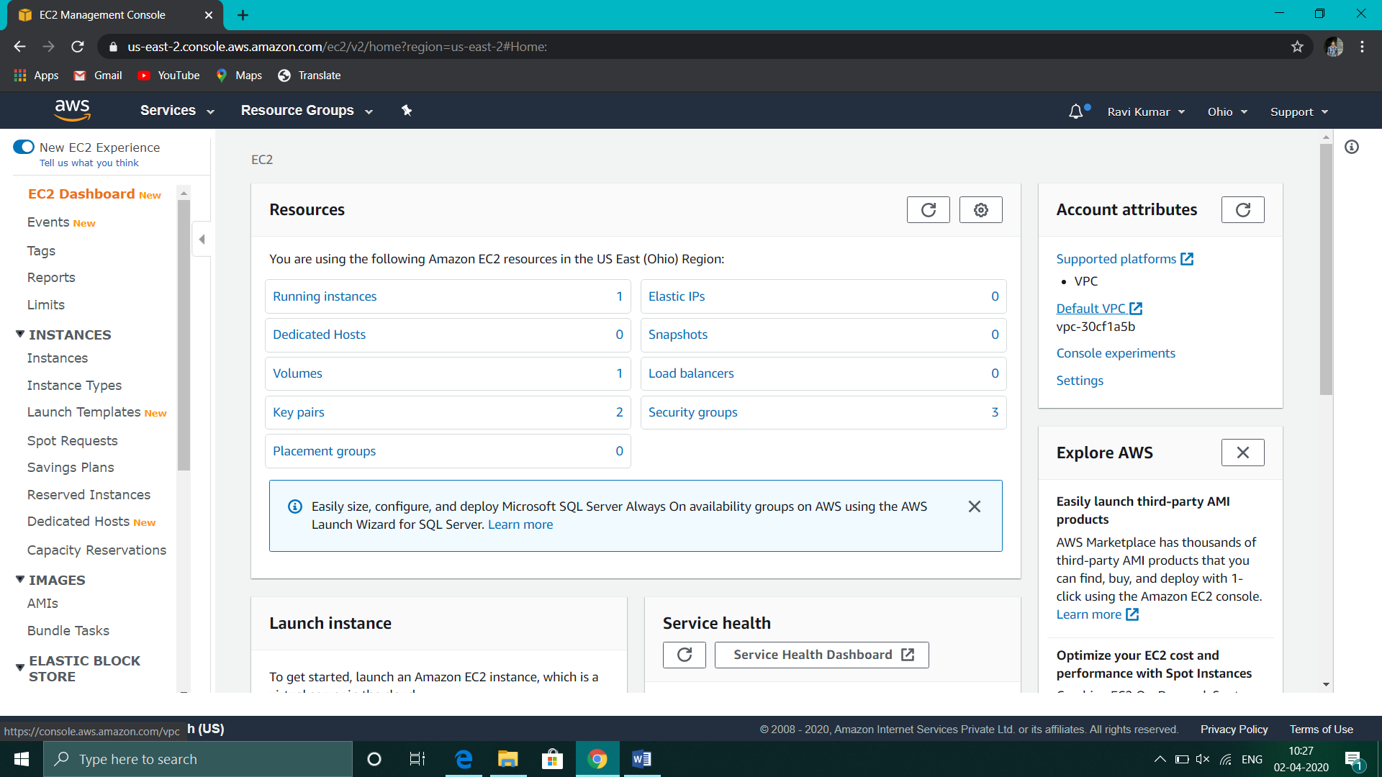

1. **S3 Dashboard**

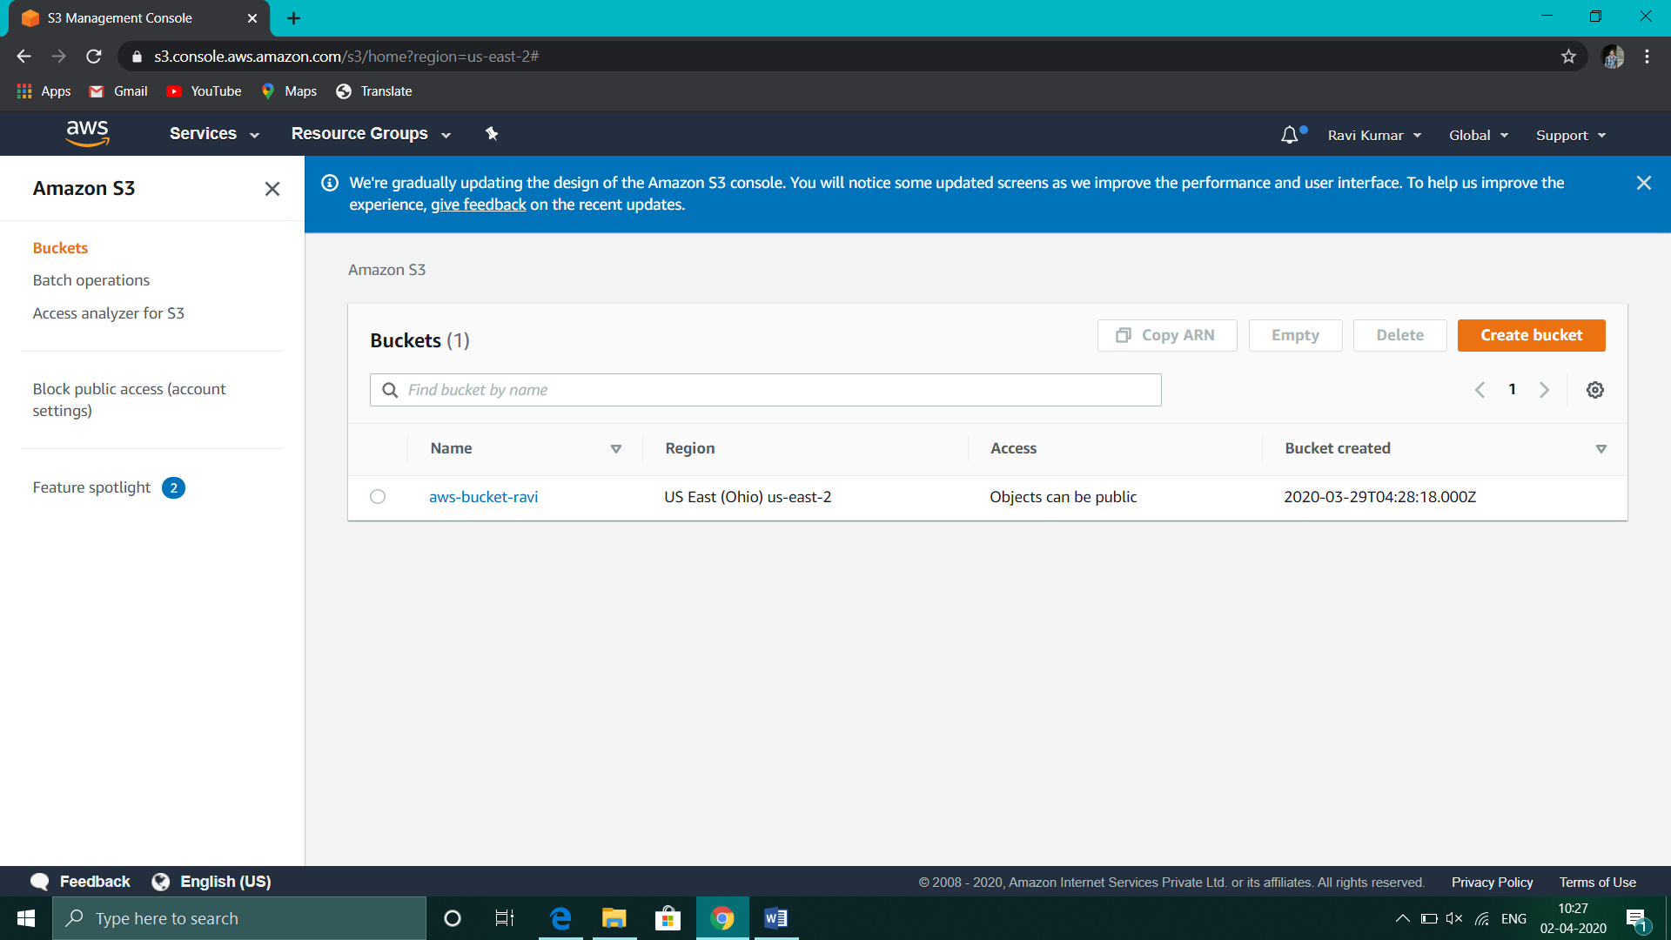

1. **Rekognition Dashboard**

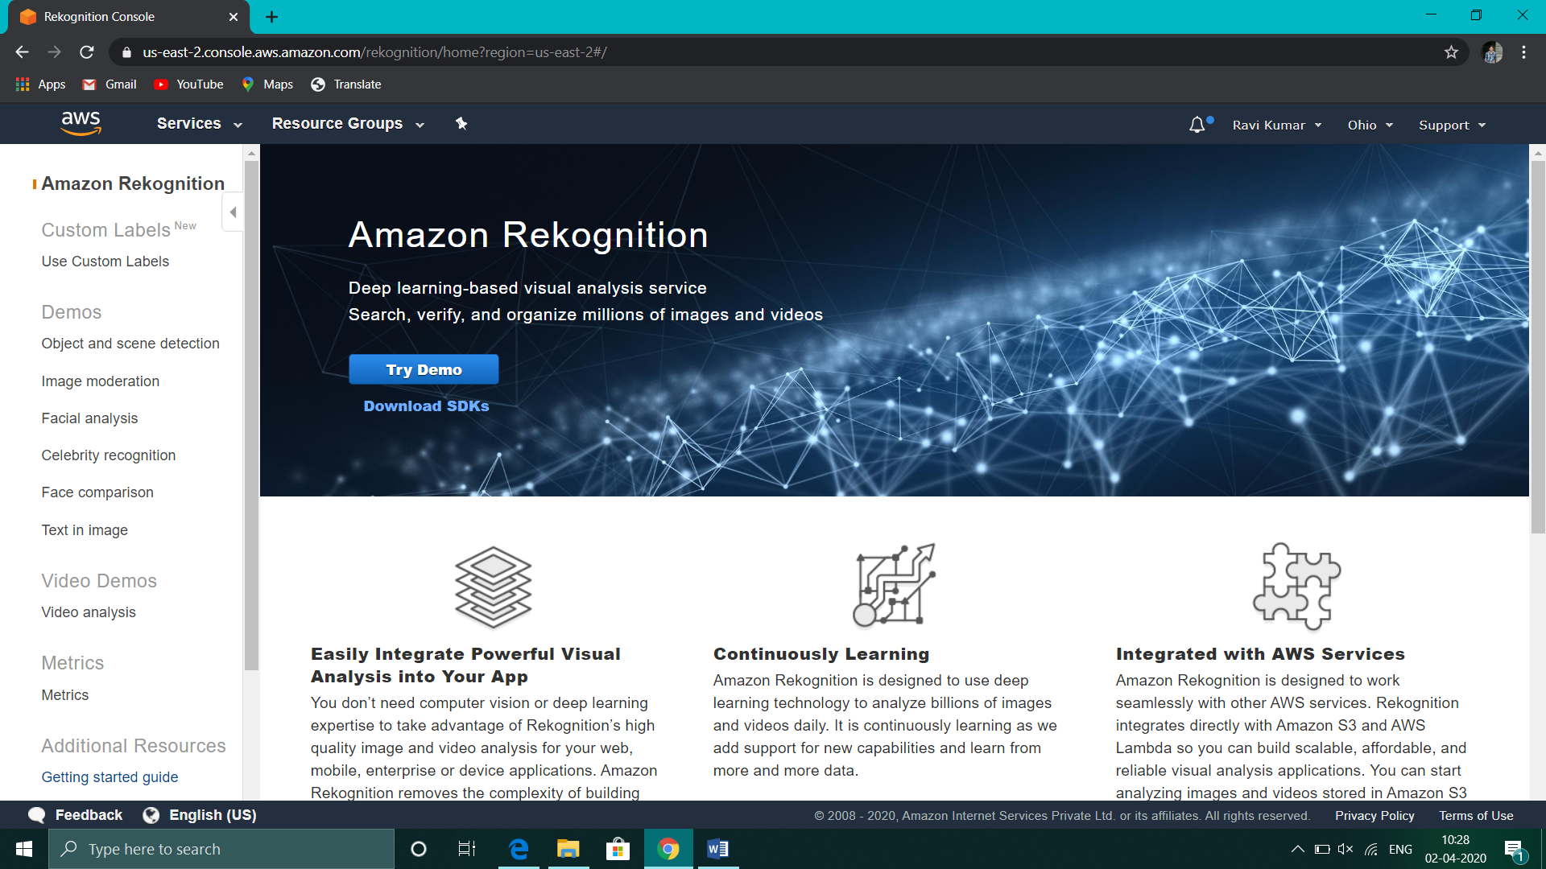

1. **ScreenShots for EC2**
2. **Choosing an AMI**

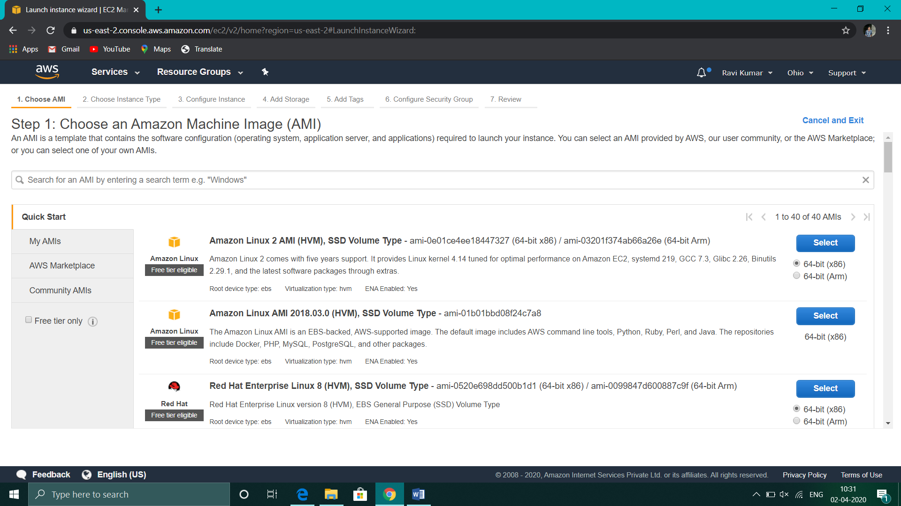

1. **Choosing an instance type**

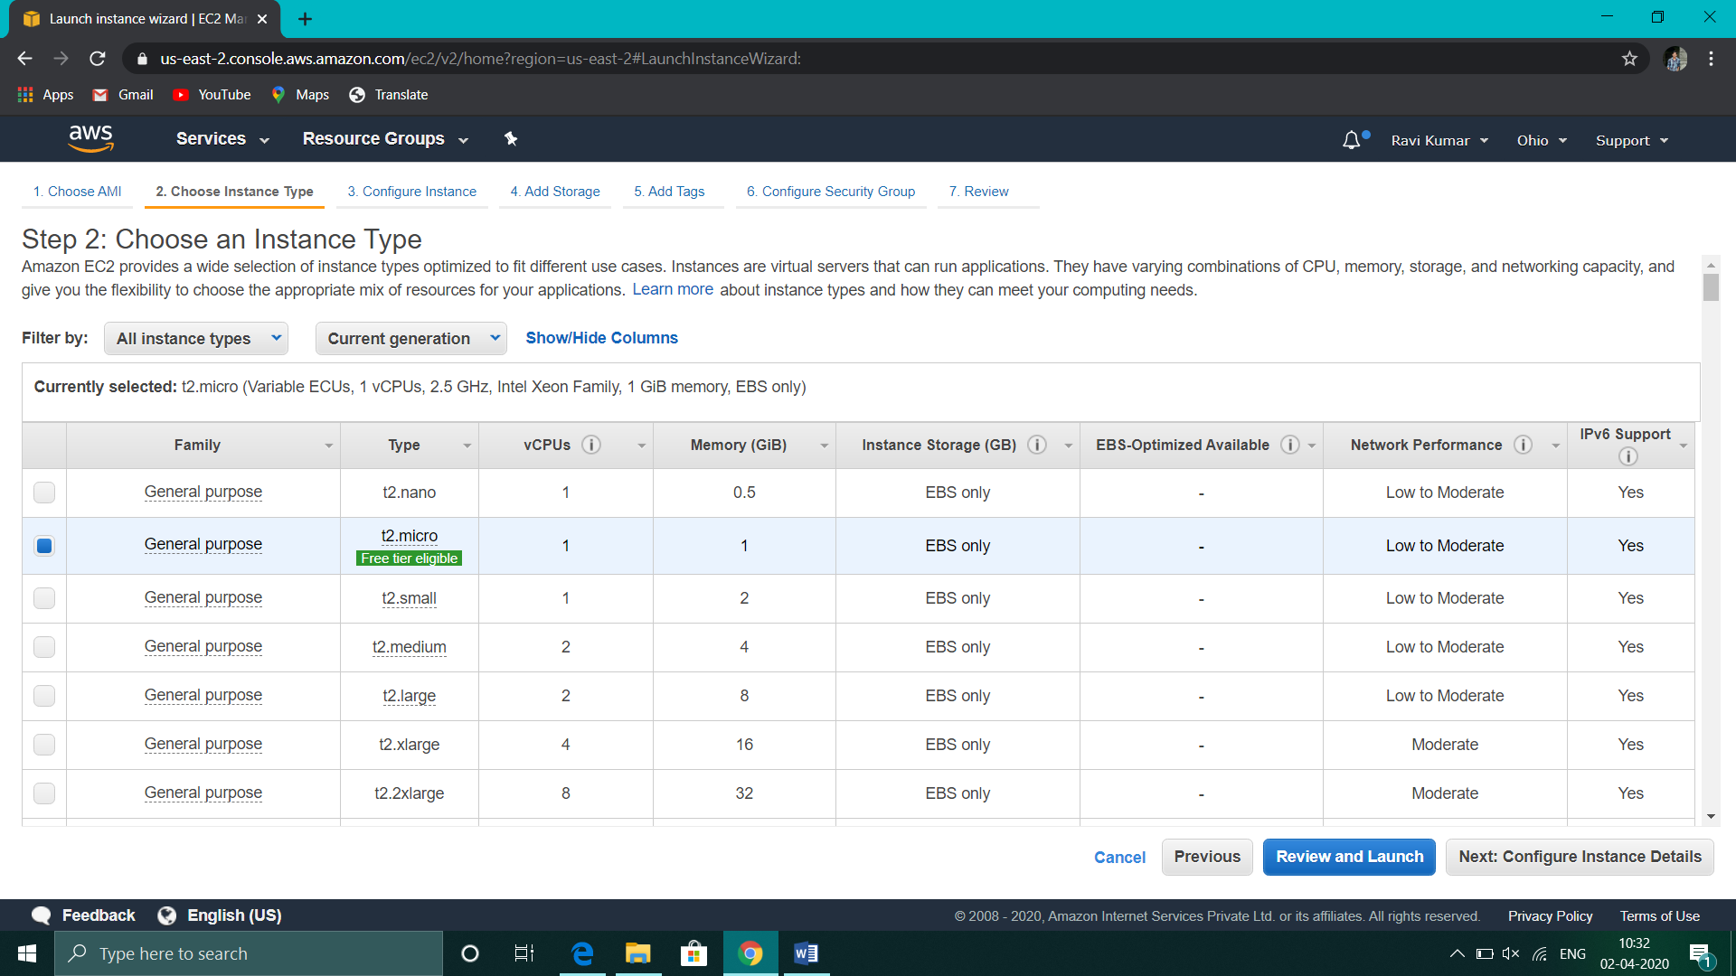

1. **Adding Storage**

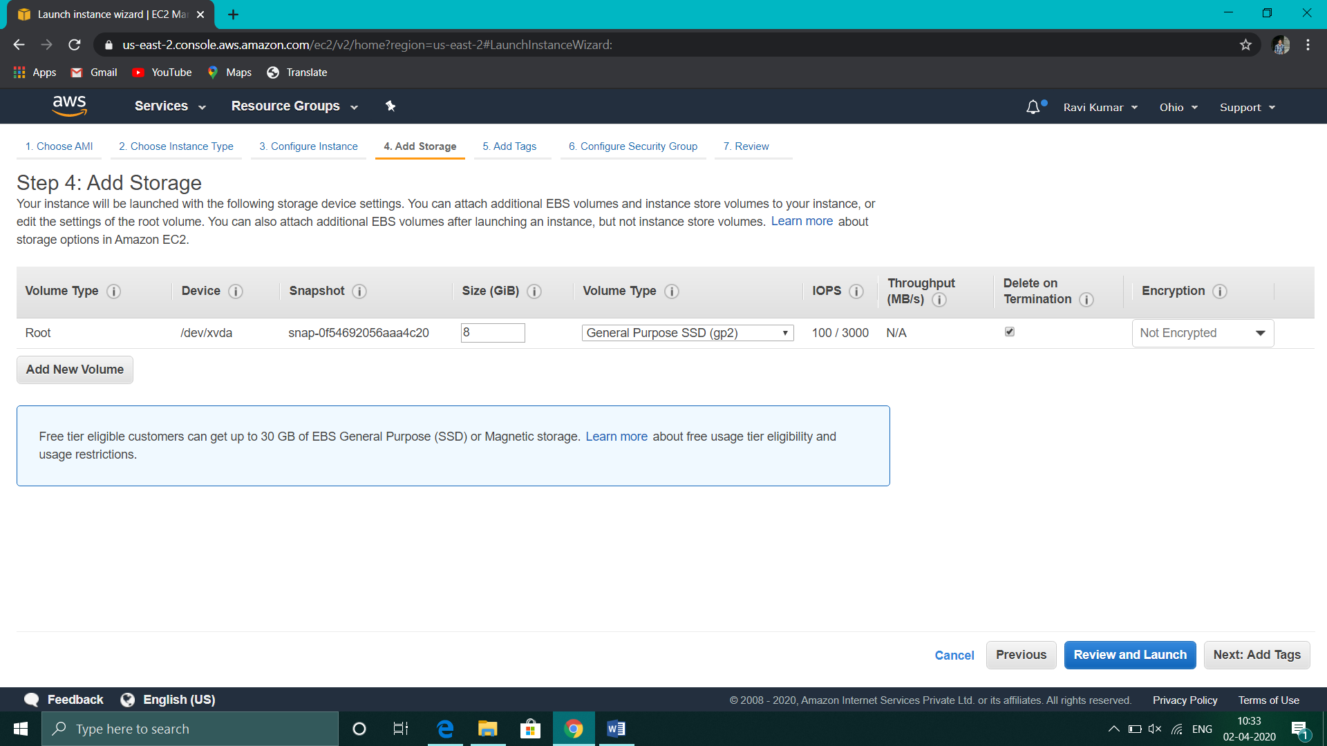

1. **Conﬁguring Security Group**

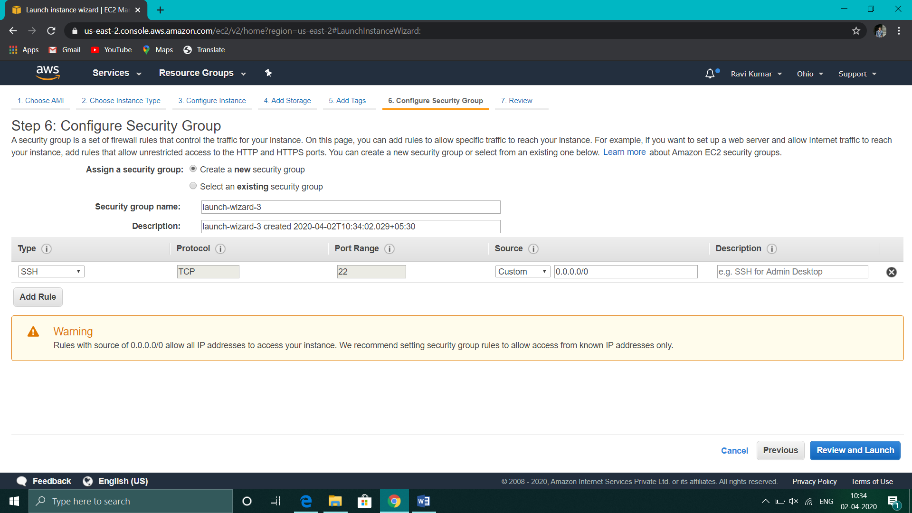

1. **Key Pair Download**

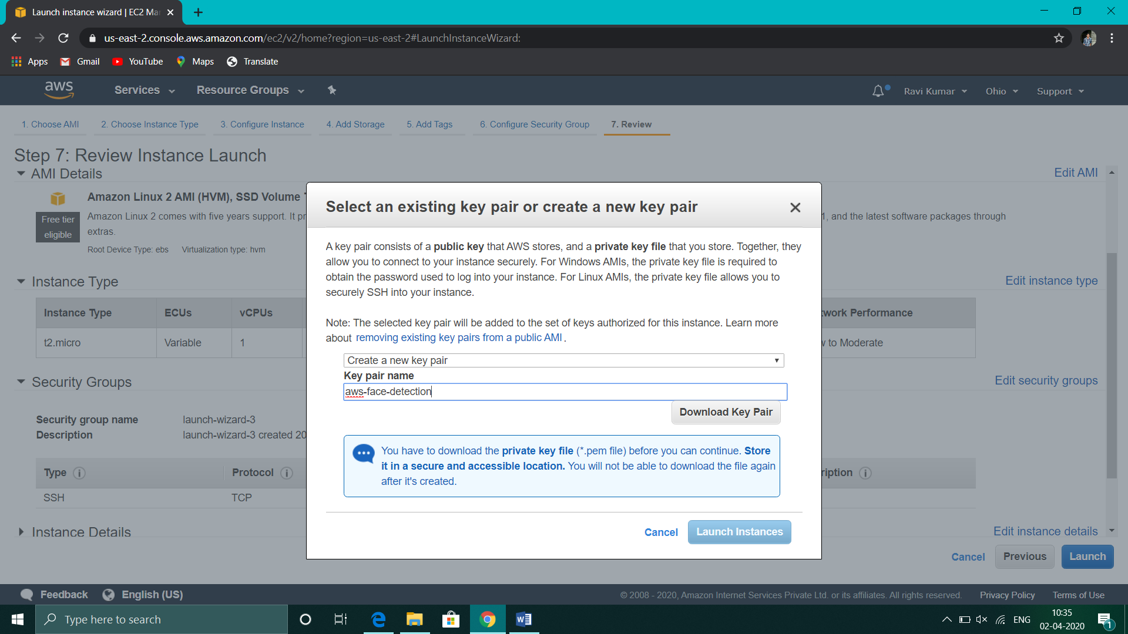

1. **PuTTYgen conversion from pem to ppk**

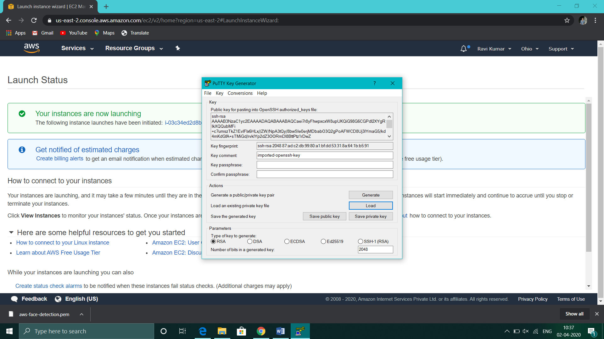

1. **Logged in EC2 blank screen**

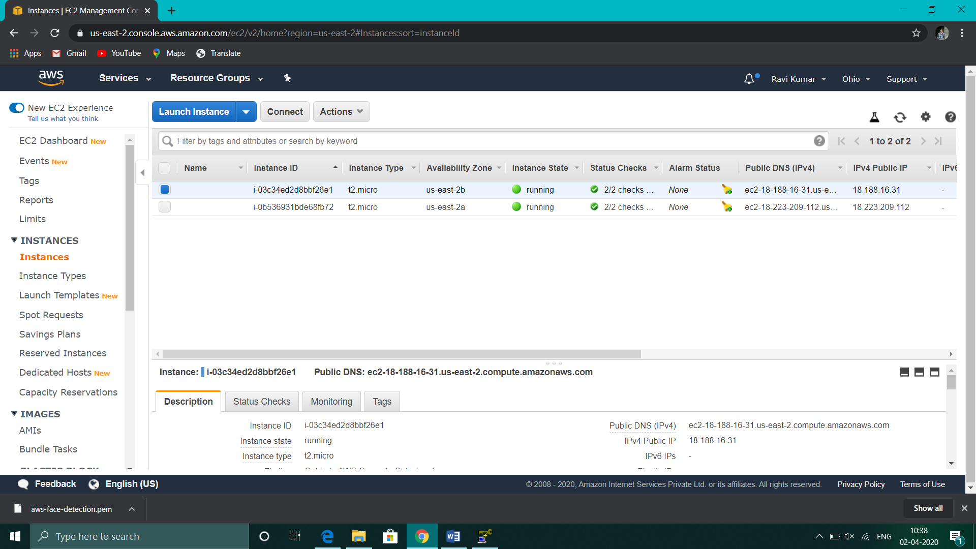

1. **Screenshots needed for S3**
2. **Creating a bucket**

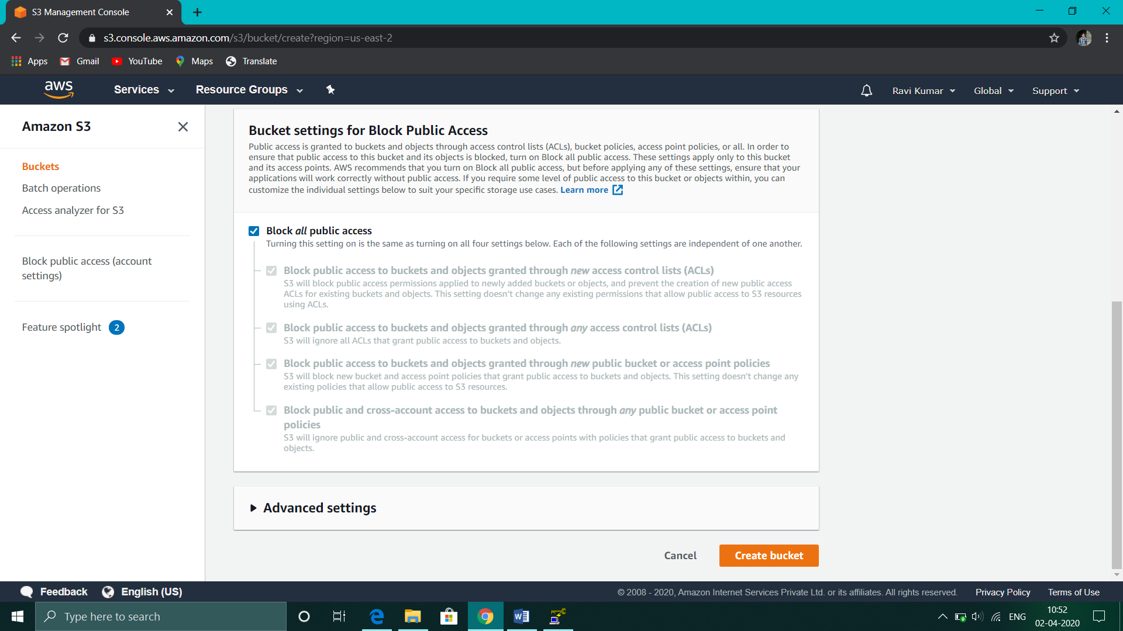



1. **Uploading an Object**

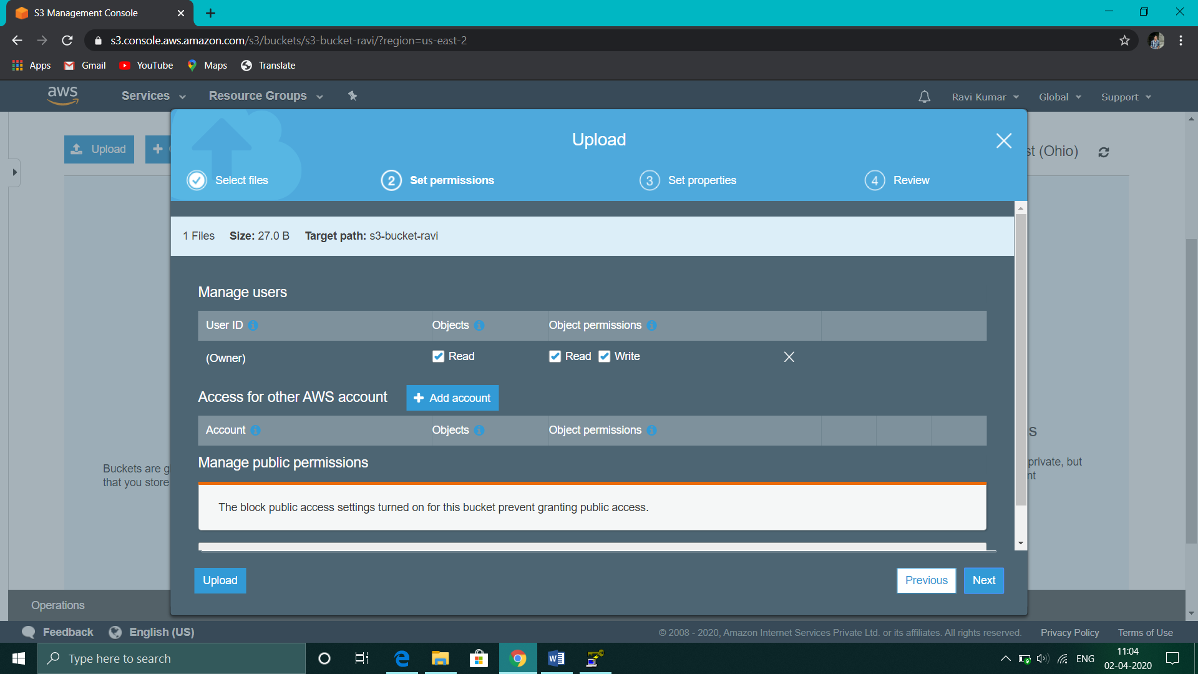

1. **Enabling Static Website**

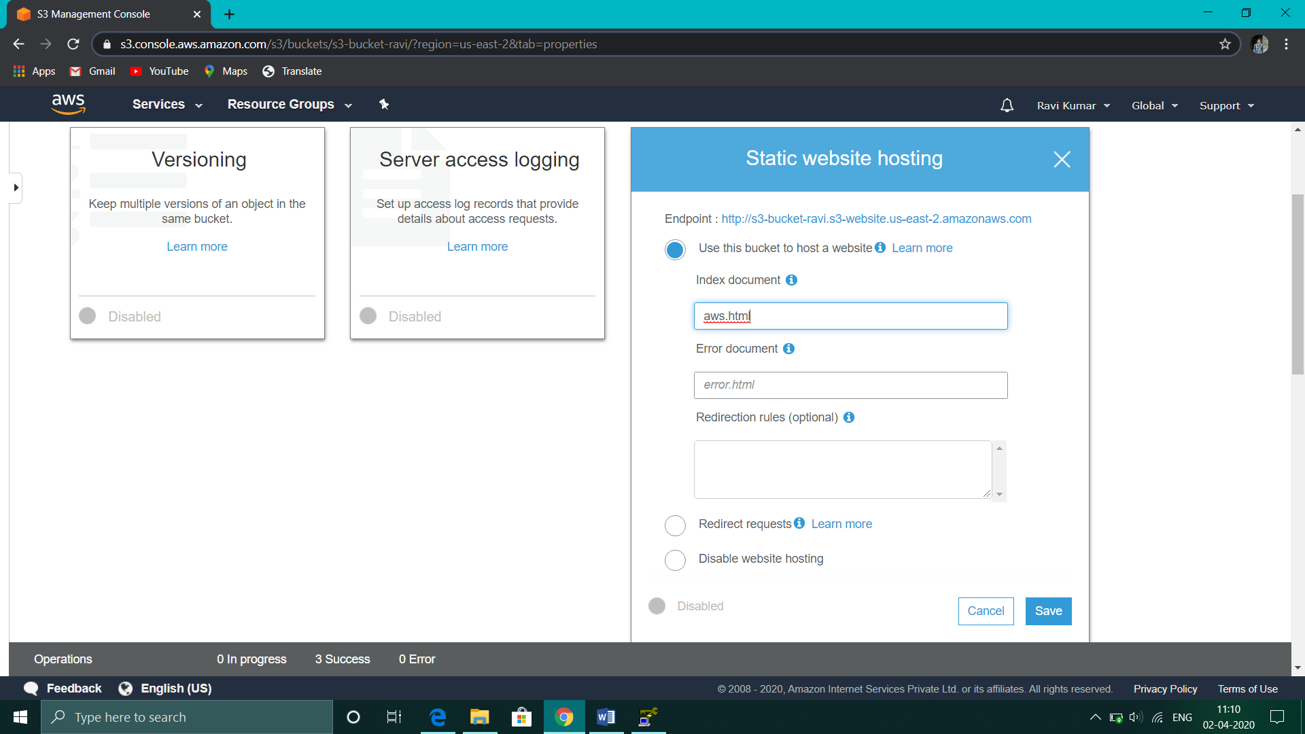

1. **Making the Object Public**

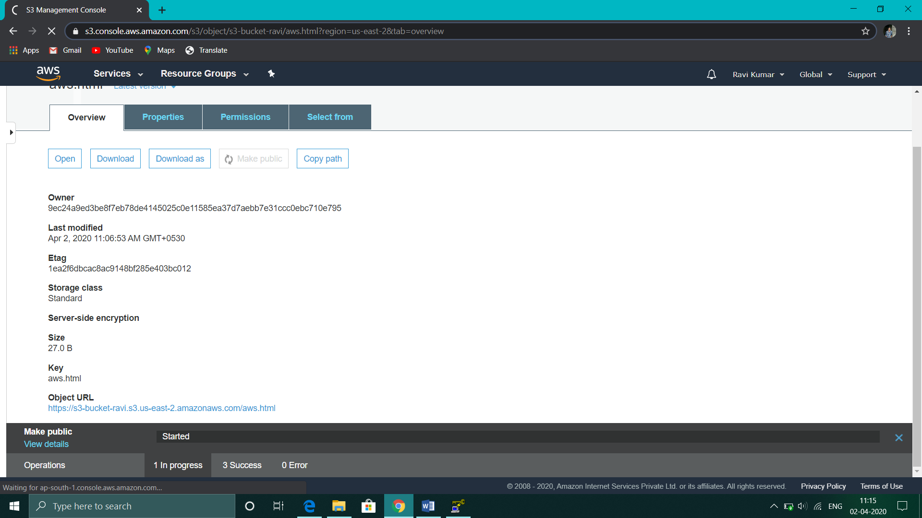

1. **Checking the S3 link on the browser**

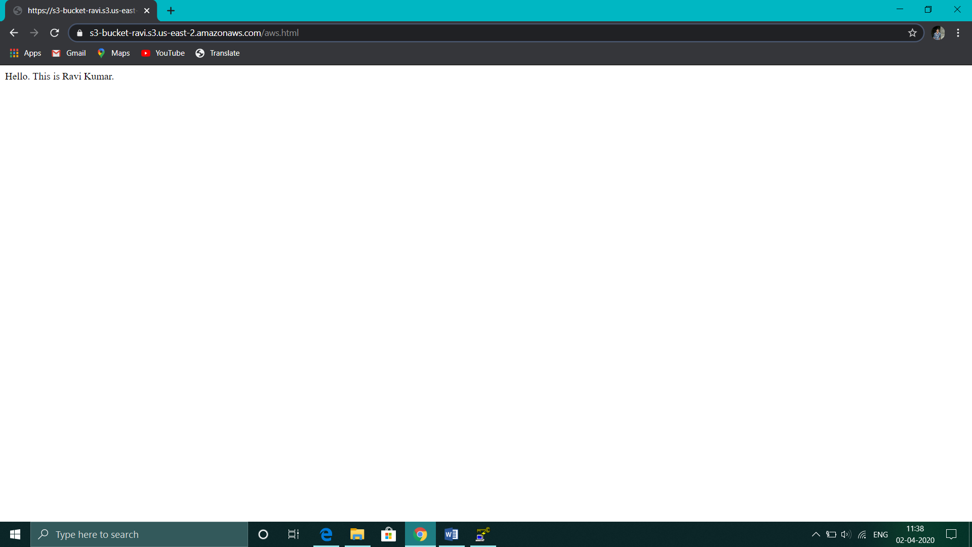

1. **Screenshots needed for Rekognition**
2. **Face Detect**

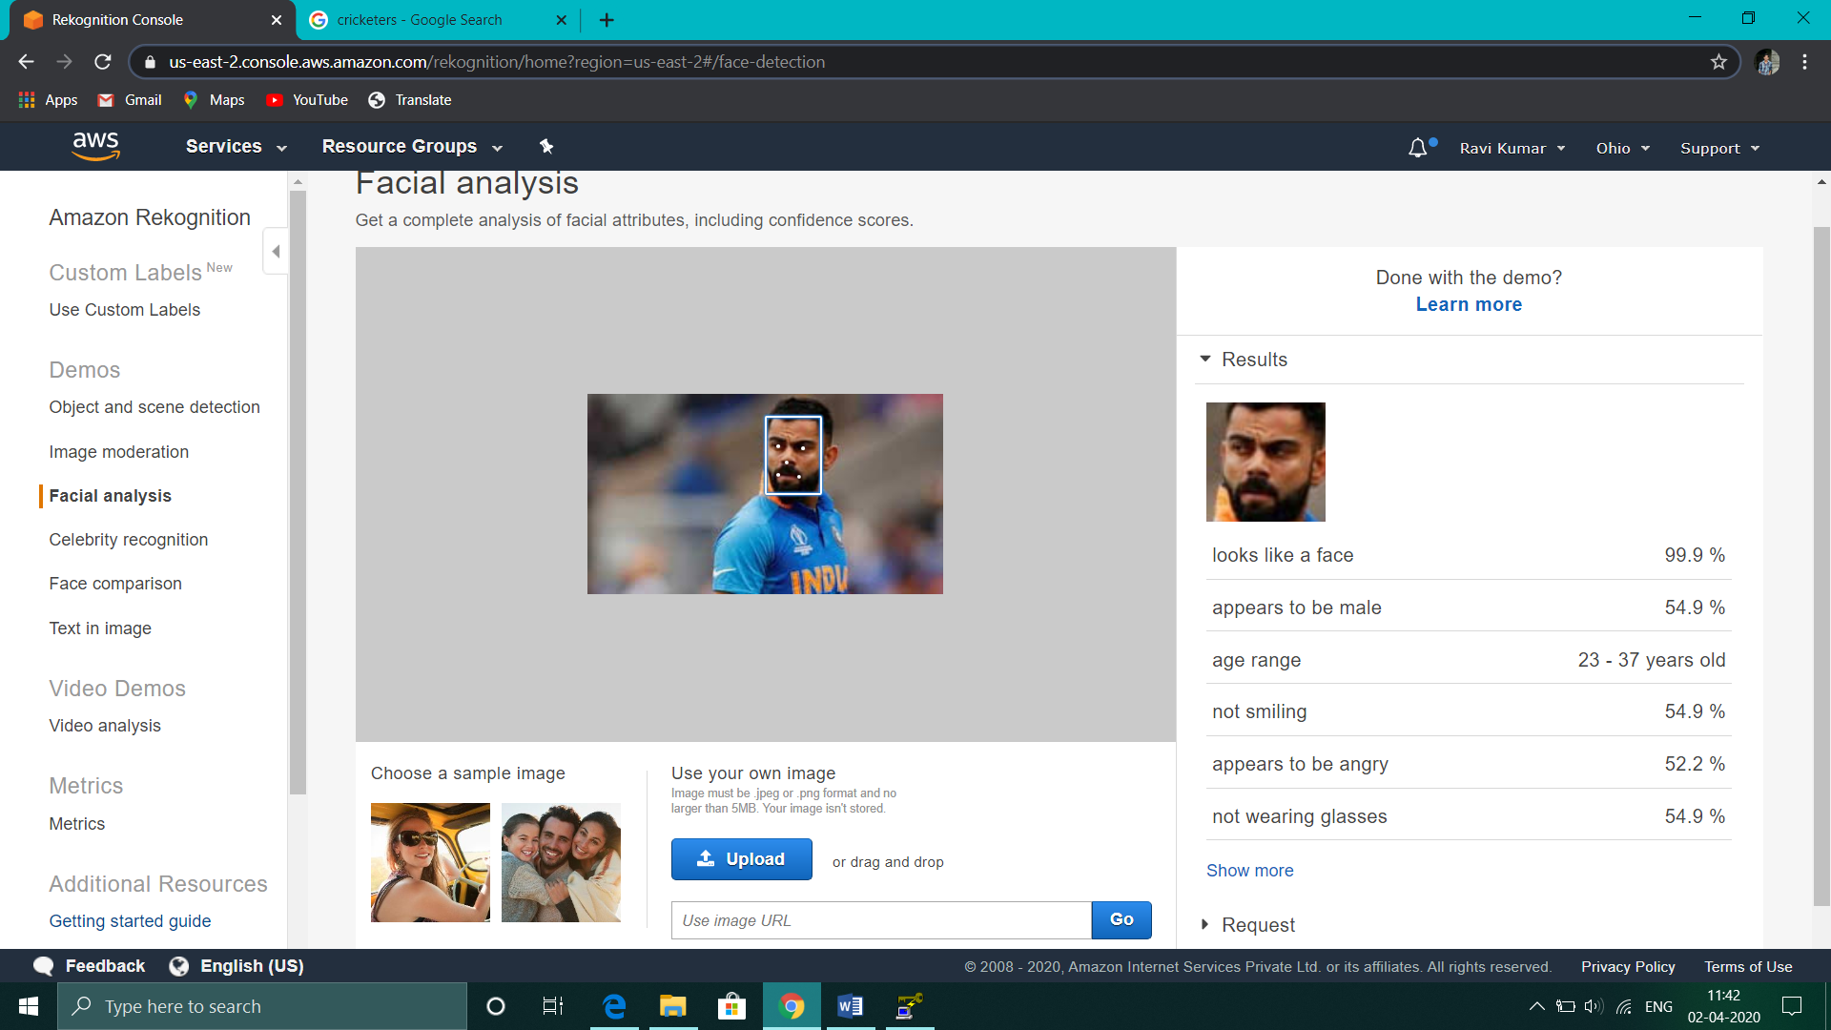

1. **Face Compare**

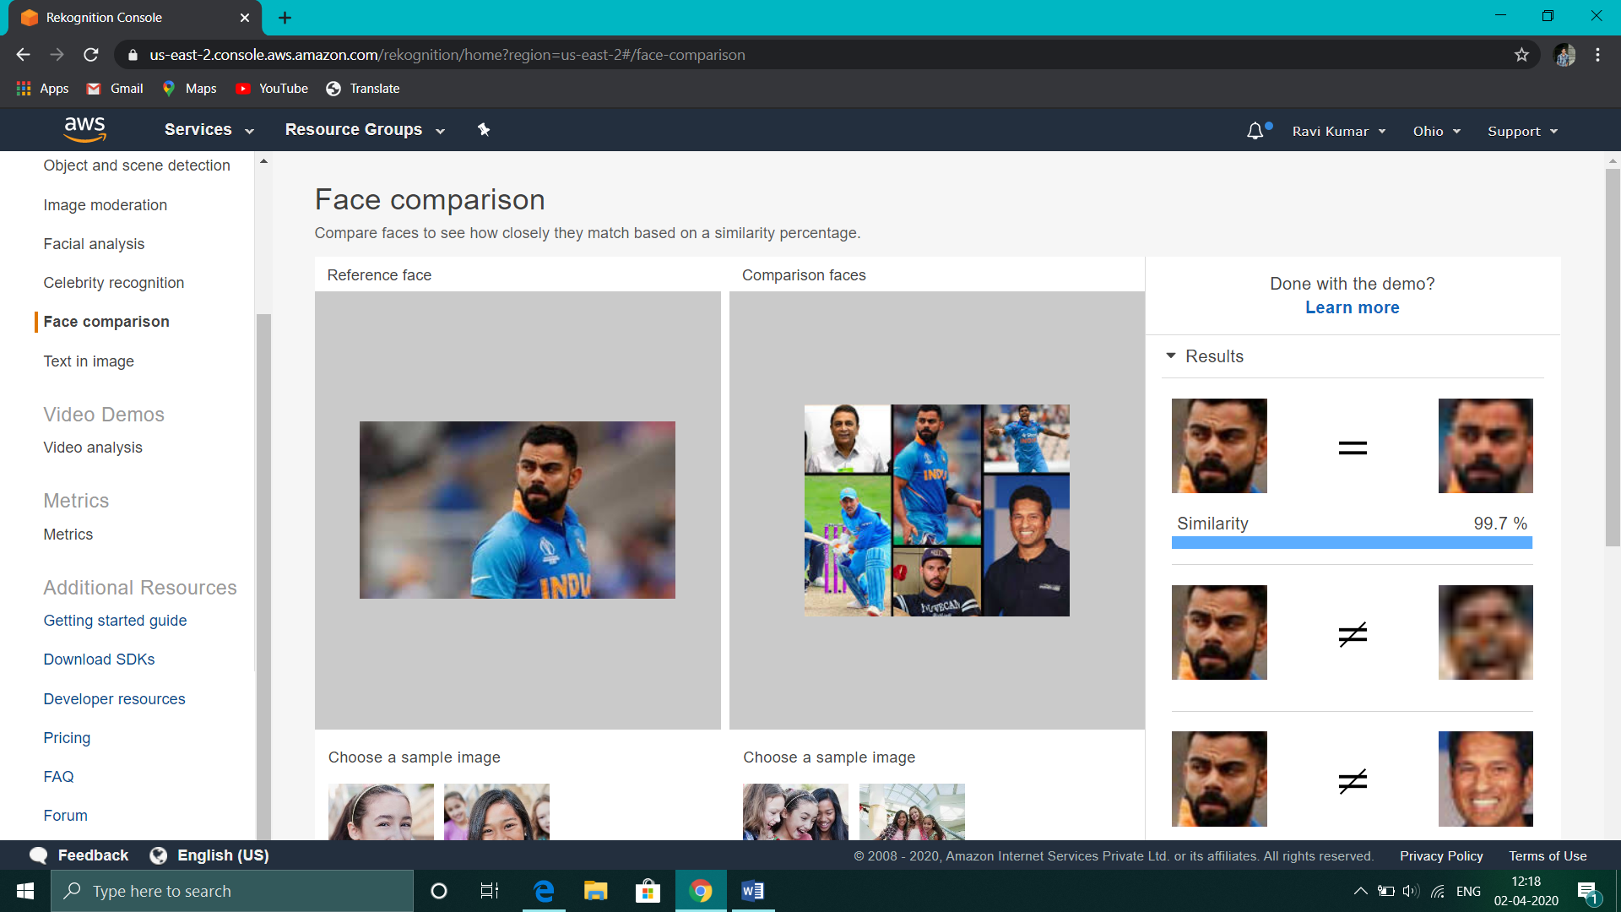

1. **Celebrity Recognition**

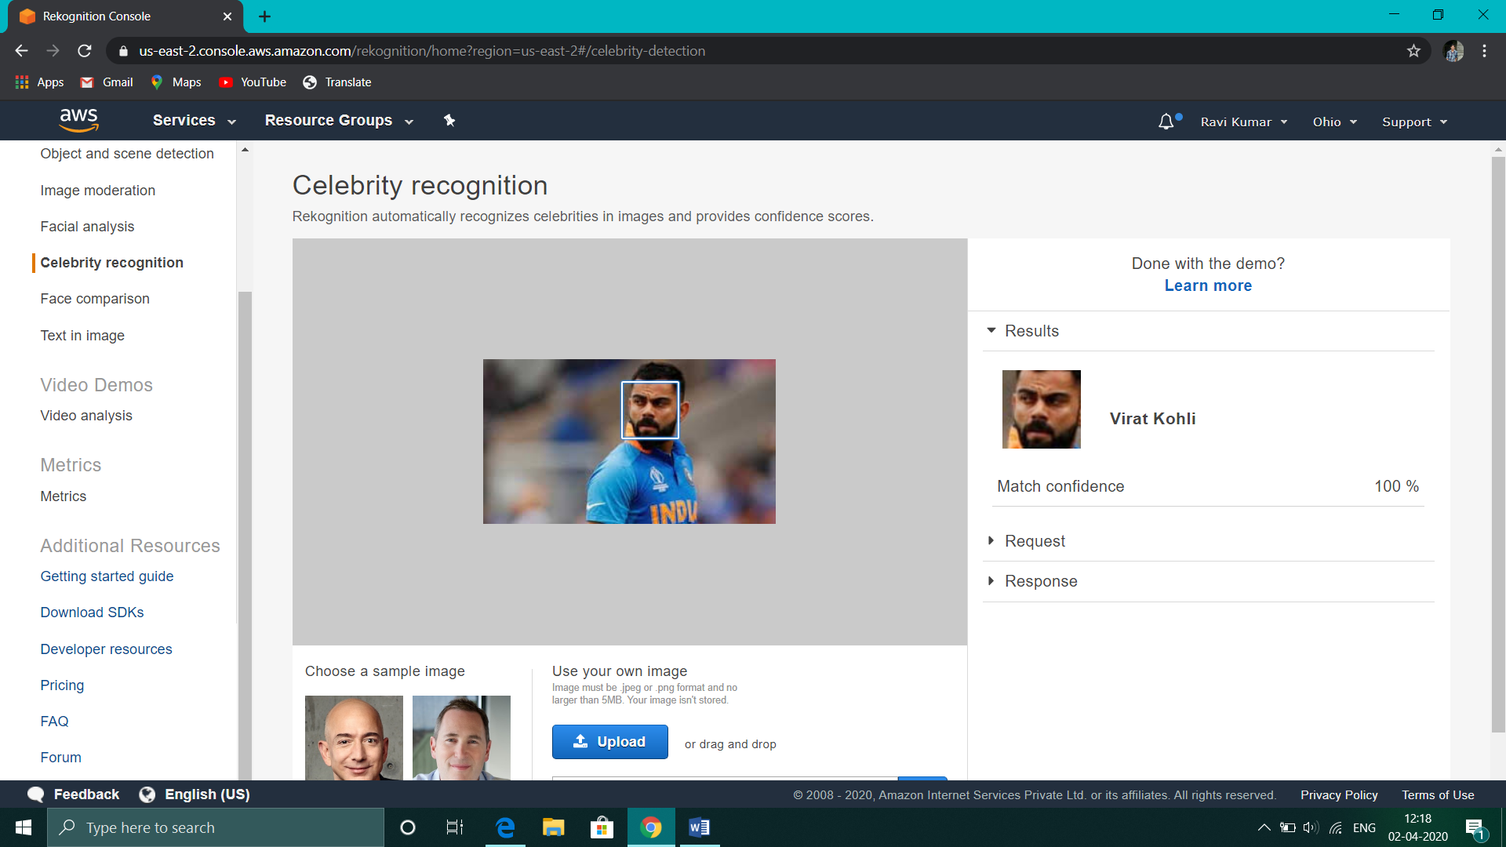

1. **Text in Image**

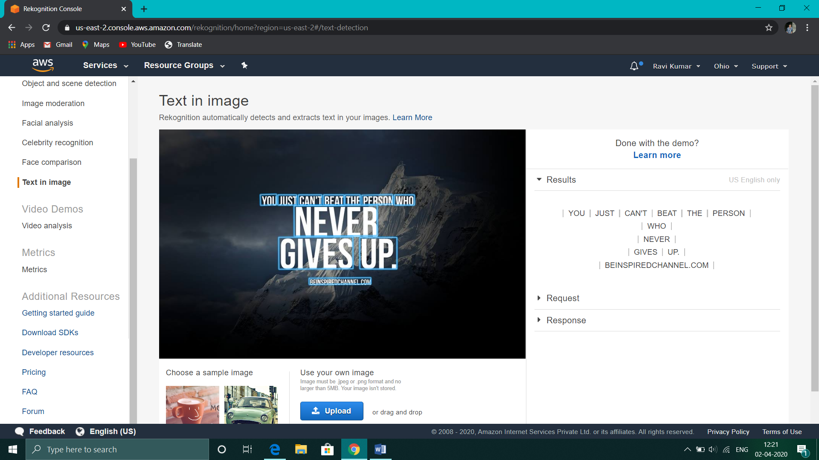

1. **Screenshots needed for EC2 & S3**
2. **Installing aws-sdk**

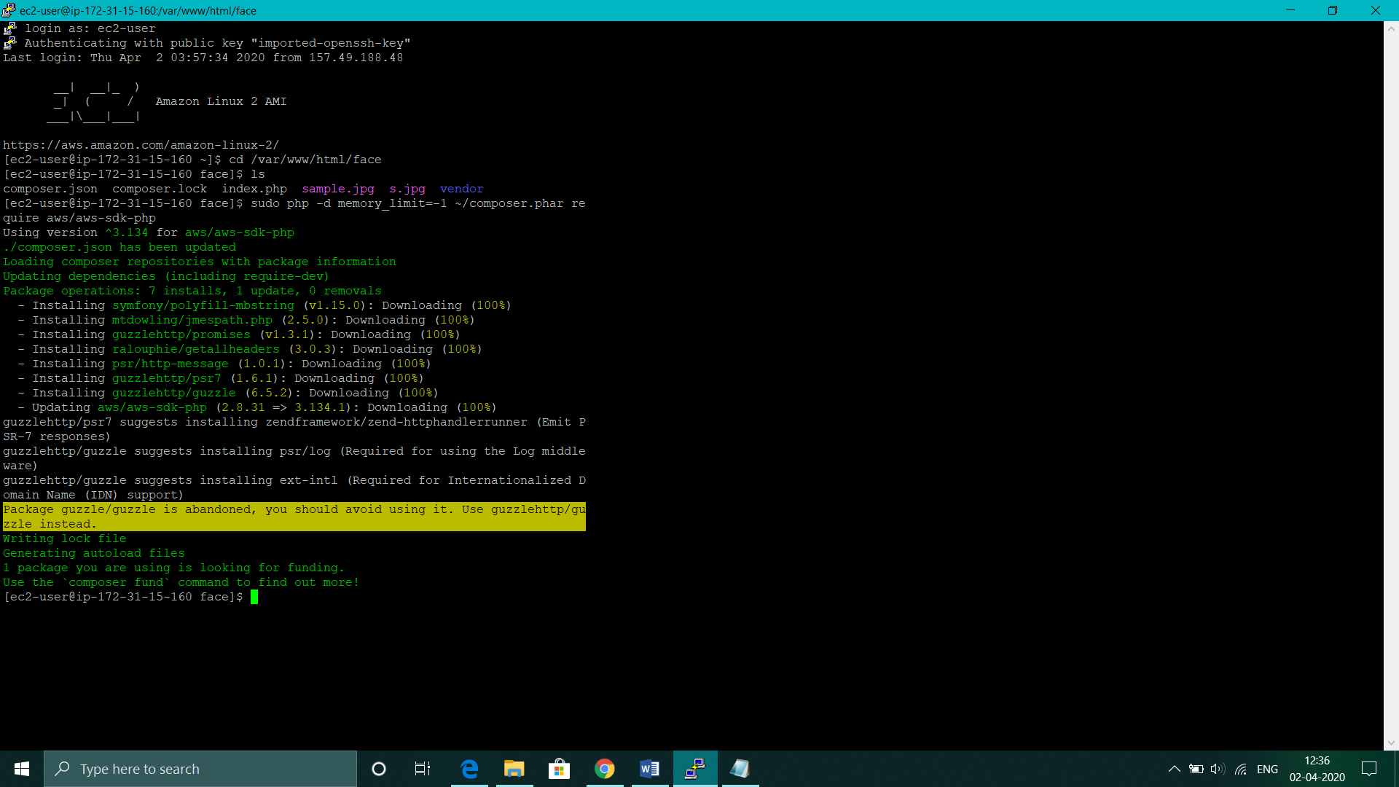

1. **Installing PHP**

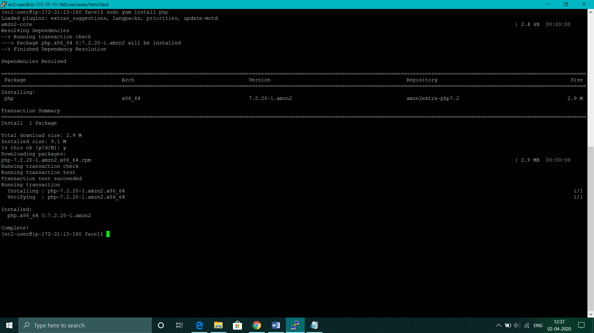

1. **index.php ﬁle code**

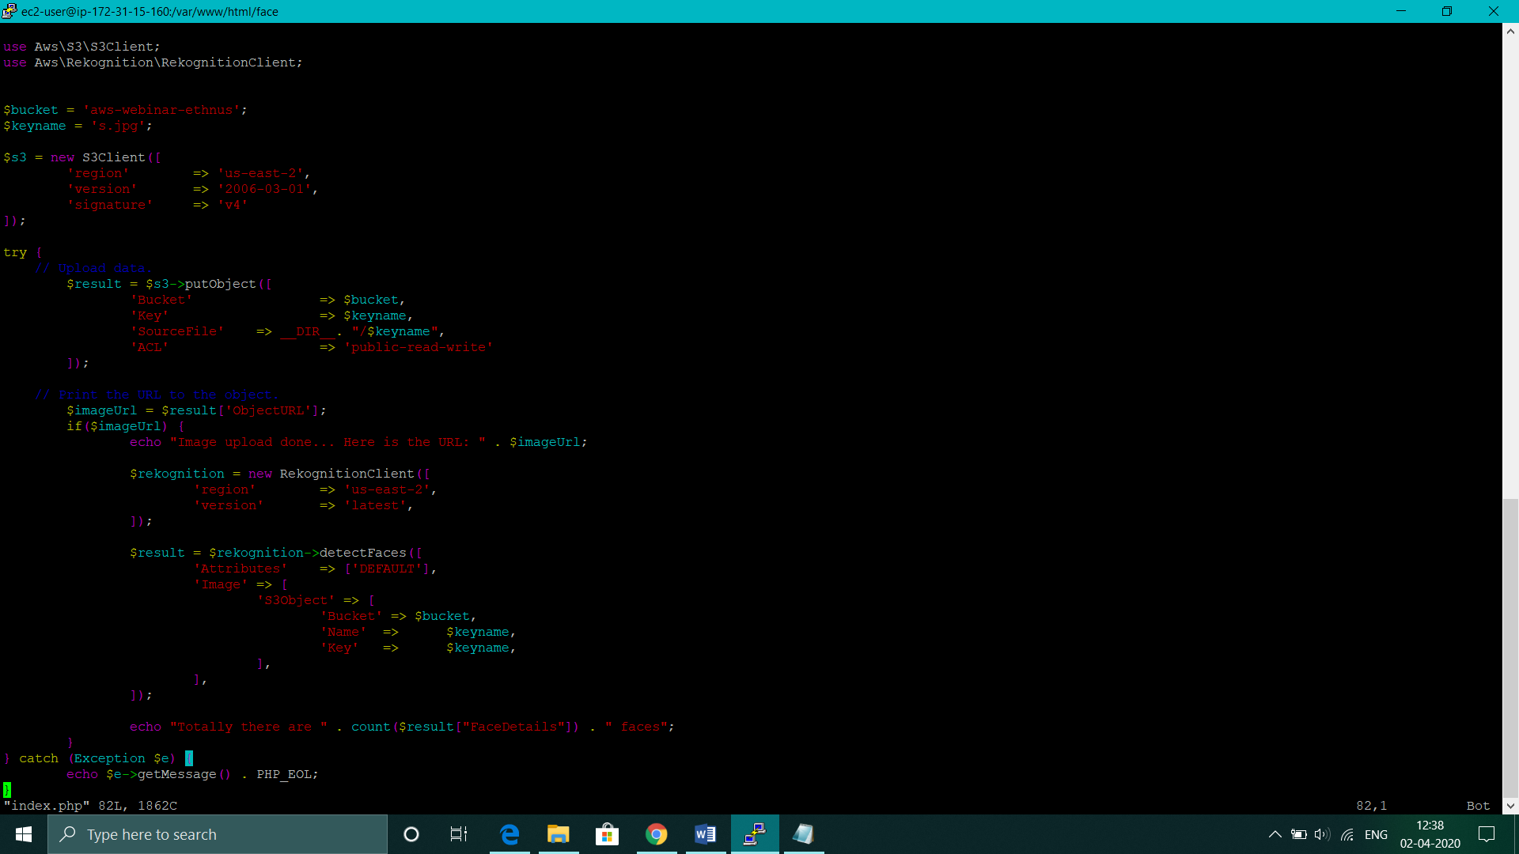

1. **Upload success screenshot**

